The Testing Roadmap

**Topic:** Research on Chest X-rays to deduct various respiratory infections

Utilization of Machine Learning is common in all the fields including health care but most hospitals are not currently deploying machine learning solutions. One reason for this is that health care professionals often lack the machine learning expertise that is necessary to build a successful model. In order to make machine learning techniques easier to apply and to reduce the demand for human experts. Most of the models wants a human interaction in each stage to add, deploy and run the model. Don’t we run the machine learning models without human interaction in such a way that a model should take input from the user and run on its own way to give output? Yes, we have automated machine learning (AutoML) has emerged as a growing field that seeks to automatically select, compose, and parametrize machine learning models, so as to achieve optimal performance on a given task and/or dataset.

The Auto Machine Learning is technique that machine will run the code by taking the input from user. In this pipeline it will take set of filtered chest images as input and it will run couple of Machine Learning models to detect and report the severity of the disease. There are several key challenges to applying machine learning in the healthcare space that make it very difficult to deploy AutoML solutions. An important challenge in any machine learning problem is assembling a high-quality, representative, and diverse dataset. Ideally, the machine learning model would be trained with data that exactly matches the format and quality of data that would be used at a later point.

Using Machine learning model in health care department is not popular now a days because of not having ML experts in health care department and the models are not giving the accurate performance and the main reason for this is lack of data. If the person wants to run the ML model he should have idea on what we are running and how we have to run the model. But if we have a model or Auto ML technique it will be easy to run and get the results.

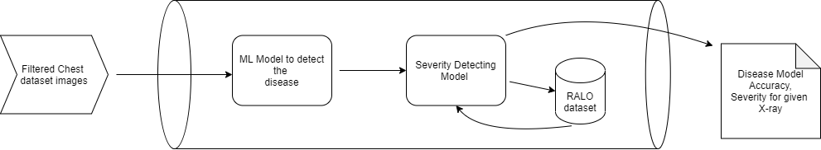

Based on that idea I am going develop this model that will take set of dataset images to run the Auto ML model. In the next step, one ML model will run on the given dataset and will give the accuracy of the disease model. Apart from that accuracy it will give input chest x-rays to another model that will calculate the severity of the disease inside the chest x-rays.

**Testing of AutoML Pipeline:**

Testing and training dataset will be the different once the training works fine then we have to provide the testing dataset to test the accuracy of the both models inside the pipeline. We will compare the testing and training accuracy of the whole model.

**Sample Expected Outputs:**

**Filter output:**

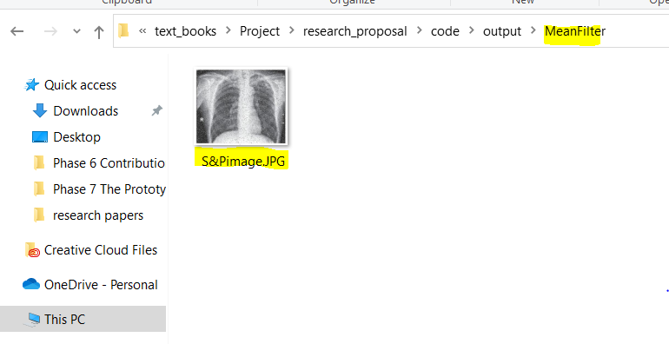

**Detection model output:**

**Accuracy: 80.678%**

**Test Accuracy: 75.890%**

**Sample Severity Output:**

|  |  |
| --- | --- |
| Image Name | sampleImage.jpg |
| Extent of lung | 2.6 |
| Opacity | 4 |